Hardware Study Guide 2
Name:______________________ Total Points

Multiple Choice: Circle the best answer.
- What was the first “storage” device
  - Flash drive b. Tape c. Punched Card d. HDD
- Primary storage is
  - SSD b. HDD c. RAM d. CD
- A Bit is
  - Equal to a byte b. Larges form in computer c. Smallest form in computer
- How many Bits equal a Byte
  - 8 b. 2 c. 16 d. 4
- What is the “brain” of a computer
  - Motherboard b. CPU c. RAM d. HDD

Short Answer: Complete each question with your best answer.
- What does SSD stand for:__________________________________________________________
- What is secondary storage: ________________________________________________________
- What does HDD stand for: ________________________________________________________
- What is an example of secondary storage: ____________________________________________
- What is an HDMI: ________________________________________________________

- What is primary storage: _________________________________________________________

- How many bits are equal to 22 bytes ____________

Matching: Label the answers to the correct ports.

Port Labeling
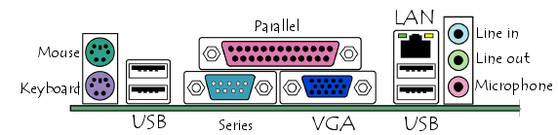
Serial
Parallel Port VGA Port USB Serial Port
PS/2 (Mouse, Keyboard) Microphone RJ45(Eathernet)
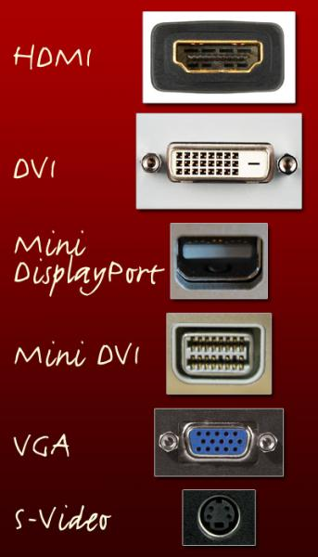
Line In Line Out

Use the following words and place them next to the pictures.

DVI
HDMI
VGA
Mini Display Port
S-Video
Mini DVI

Labeling: label the following items with their correct names.
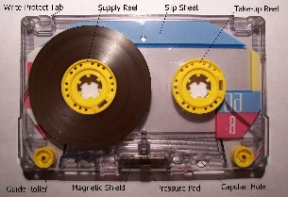1. _____________________________
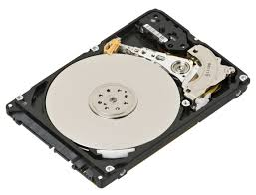2. ________________________________
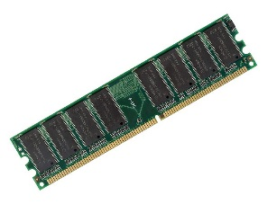3. _________________________________
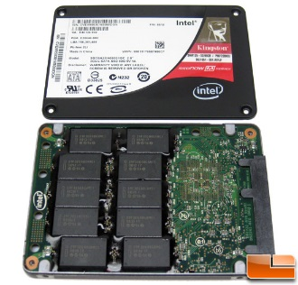4. ___________________________________
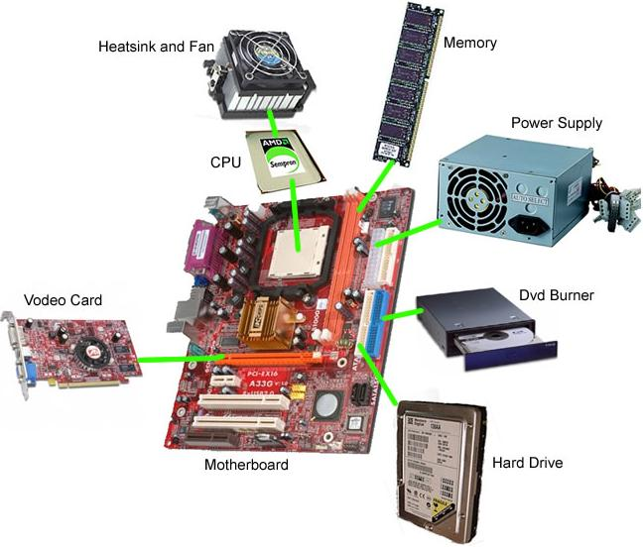
Video Card

Essay: Should be a paragraph explanation.
- How do HDD and SSD compare?

- How have gaming consoles changed over the years?

- How has the Internet changed over the years?

- How has animation changed over the years?

Find what values are needed for the numbers below or cross them out if they don’t work.
- 103
128 | 64 | 32 | 16 | 8 | 4 | 2 | 1
- 180
128 | 64 | 32 | 16 | 8 | 4 | 2 | 1

Subtraction: You must subtract the problems to get the answer. The binary should represent your answer.

- 127-87
128 | 64 | 32 | 16 | 8 | 4 | 2 | 1
- 120-103
128 | 64 | 32 | 16 | 8 | 4 | 2 | 1

Negatives: Find the negative binary code. USE THE EXTRA BOXES TO SHOW WORK

- Show a -53
128 | 64 | 32 | 16 | 8 | 4 | 2 | 1

